SQL Developer
Task 7 - Views Documentation
Name: Aryan Rahate
📋 Project Overview
Create and use SQL views to simplify data analysis and store reusable query logic.

Task Queries
Task 1: Create View for Student Scores
sql
-- View 1: Comprehensive student scores view
CREATE VIEW student_scores AS
SELECT
studentid, name,
grade, mathscore,
sciencescore,englishscore,
(mathscore + sciencescore + englishscore) as total_score
FROM students;

Output:
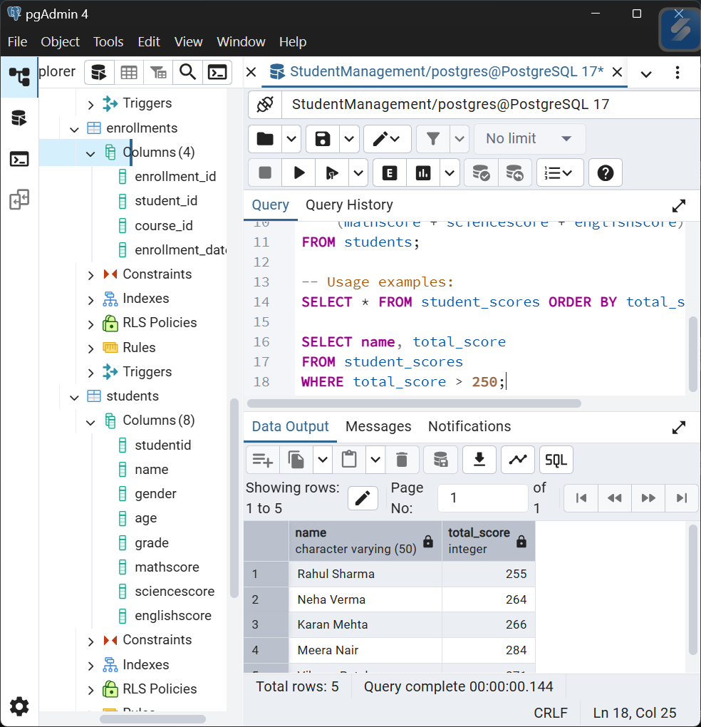

Task 2: Create View for Students Who Passed All Subjects
sql
-- View 2: Students who passed all subjects (score >= 40 in each)
CREATE VIEW passed_students AS
SELECT
studentid,
name,
grade,
mathscore,
sciencescore,
englishscore,
(mathscore + sciencescore + englishscore) as total_score
FROM students
WHERE mathscore >= 40
AND sciencescore >= 40
AND englishscore >= 40;

Output:
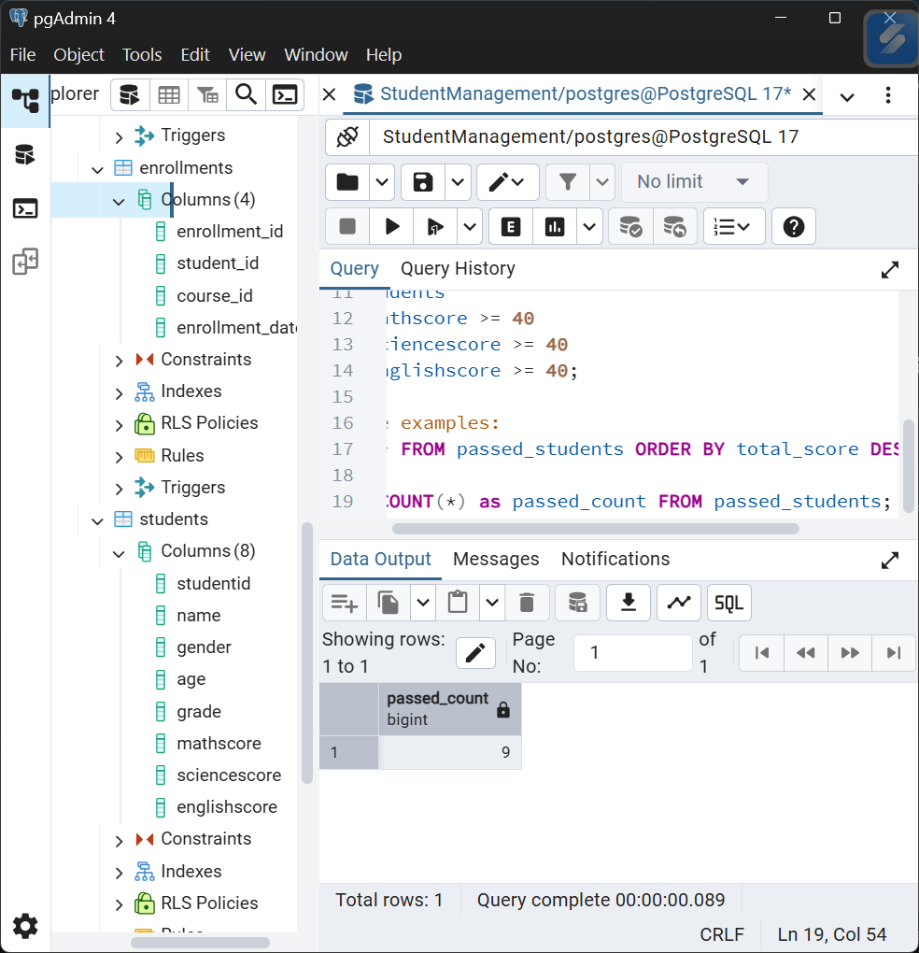
Expected Results
student_scores View:
- Records: 10 students (all students from the table)
- Columns: studentid, name, grade, mathscore, sciencescore, englishscore, total_score
passed_students View:
- Records: Based on current data, all 10 students should pass (all scores ≥40)
- Pass Rate: 100% (all students meet passing criteria)

Summary of Findings
View Benefits:
- Simplified Access: Complex queries encapsulated in reusable views
- Data Security: Controlled access to specific data columns
- Performance: Pre-compiled queries for faster execution
- Maintainability: Centralized logic for easier updates
Key Insights:
- 100% Pass Rate: All students pass individual subjects with 40 threshold
- Performance Range: Total scores range from 187 to 284
- Grade Distribution: Multiple performance levels despite universal passing
Practical Applications:
- Academic Reporting: Quick access to student performance data
- Admissions: Easy filtering of qualified students
- Analytics: Simplified data for further analysis and reporting
Views successfully created and validated for efficient student data management.

